`./

**Learning Report**

Linux OS & Programming



Version Number:

Team Members :

Team No:

Module: Model Based System Engineering

|  |  |  |  |  |  |
| --- | --- | --- | --- | --- | --- |
| **Ver. Rel. No.** | **Release Date** | **Prepared. By** | **Reviewed By** | **To be Approved By** | **Remarks/Revision Details** |
| 1 | 1-03-21 | N. Vishaal Balaji | Reeshav Rout, Devraj Sen |  |  |
| 2 | 2-03-21 | N. Vishaal Balaji | Mohammadhassan Zaffar, Nikitha Reddy Amaram |  |  |
| 3 | 6-03-21 | N. Vishaal Balaji |  |  |  |
|  |  |  |  |  |  |
|  |  |  |  |  |  |

**Document History**

Contents

Contents 3

Activities 4

Activity 1 – Makefile , Static and Dynamic Linking 4

**ACTIVITY 2 - SYSTEMCALLS, PROCESS AND THREADS………………………………………………………………………………….6**

**ACTIVITY 3 - MUTEX, SEMAPHORES, RACE CONDITION, PIPES…………………………………………………………………….7**

# Activities

# Activity 1 – Makefile , Static and Dynamic Linking

# 

**Part A - Preparation**

**Part B - Simple Make file**

**Part C- Simple Make file with Inc and Src Folders**

**Part D- Static Libraries**

**Part E- Dynamic Libraries**

**GitHub Link : https://github.com/99003694/Activity1_Linux**

**Commands used:**

* For producing .out and .o files (dep = dependencies)

>> gcc dep1.c dep2.c dep3.c

* For executing the output considering a.out is the executable file

>> ./a.out

* For creating a new file and editing

>> nano file_name

* For creating libraries

**>>** ar rc libsimple.a dep1.o dep2.o

**>>** gcc -L. dep1.o s1.out -lsimple

**>>** gcc -L. dep1.o -o s1.out -lsimple

>> gcc -L. dep1.o -o s2.out -lsimple -static

**Folder after Makefile:**

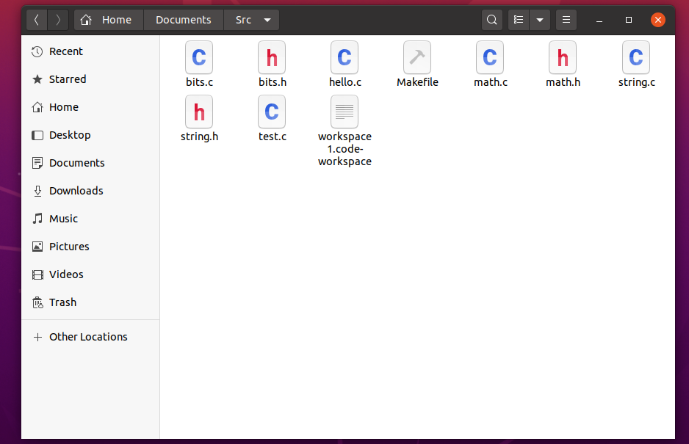

**Activity 2: Process, System calls and Threads**

**Objective:**

Concepts related to process, system calls and threads were taught and were asked to execute some programs related to the former.

**Outcome :**

learnt about process, system calls and threads.

Executed programs pertaining to the concepts learnt.

**Challenges:**

Application of correct logic and troubleshooting the errors.

**Activity Link : https://github.com/99003694/Activity1_Linux**

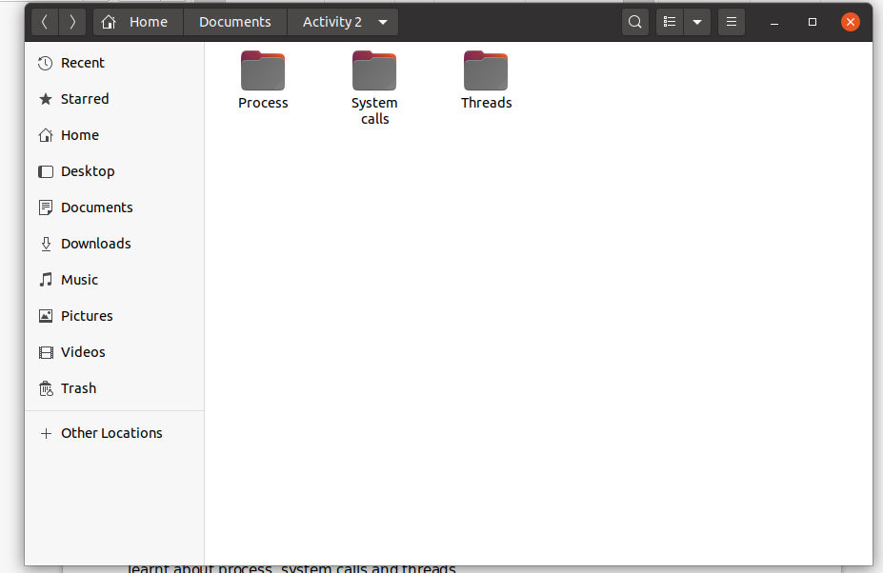

**Activity 3: Mutex, Semaphores, Deadlock, Race condition, Pipe, Message Queue, Shared memory**

**Objective:**

To understand concepts pertaining to Mutex, deadlock, race conditions, stack, queue, shared memory and semaphores.

**Outcome:**

1. Implementation of Mutex and semaphores.
2. Threads with producer and consumer concept.
3. Avoiding deadlock conditions.
4. Usage of pipes.

**Challenges faced:**

1. Understanding the concepts and implementation of mutex, semaphores.

**Github Link:**

[**https://github.com/99003694/Activity1_Linux/tree/main/Activity%203**](https://github.com/99003694/Activity1_Linux/tree/main/Activity%203)

**References:**

[**https://www.geeksforgeeks.org/semaphores-in-process-synchronization/**](https://www.geeksforgeeks.org/semaphores-in-process-synchronization/)

[**https://www.geeksforgeeks.org/mutex-vs-semaphore/**](https://www.geeksforgeeks.org/mutex-vs-semaphore/)